Session 8
Task 1
Write a PL/SQL block that declares two variables: one for a user's name (VARCHAR2) and one for their age (NUMBER). Assign values and print both using DBMS_OUTPUT.PUT_LINE.
Query
SET SERVEROUTPUT ON;
DECLARE
v_name VARCHAR2(50) := 'Saniya Khan';
v_age NUMBER := 19;
BEGIN
DBMS_OUTPUT.PUT_LINE('Name: ' || v_name);
DBMS_OUTPUT.PUT_LINE('Age: ' || v_age);
END;
/
Output:
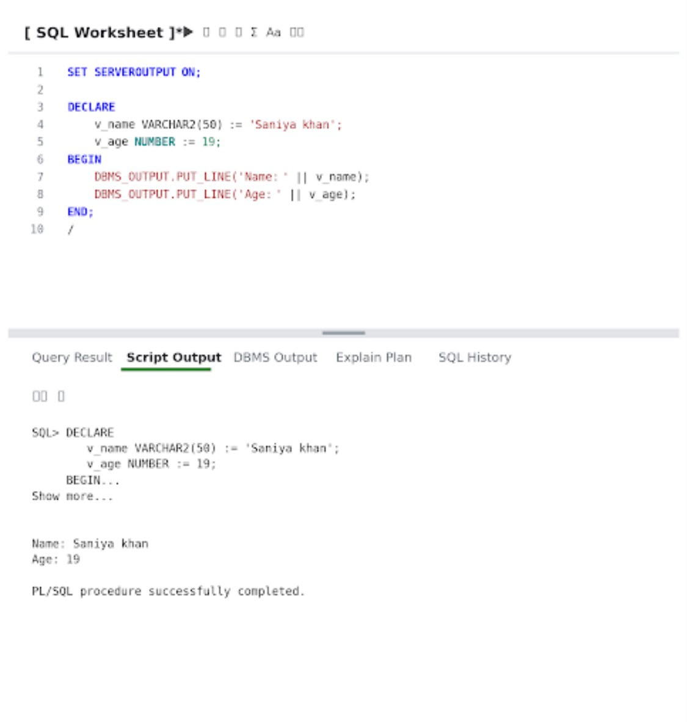
Task 2
Create a PL/SQL block that uses an IF statement to check if a given order amount is above 500. If yes, print 'Eligible for free delivery', else print 'Delivery charges apply'.
Query
SET SERVEROUTPUT ON;
DECLARE
v_amount NUMBER := 600;
BEGIN
IF v_amount > 500 THEN
DBMS_OUTPUT.PUT_LINE('Eligible for free delivery');
ELSE
DBMS_OUTPUT.PUT_LINE('Delivery charges apply');
END IF;
END;
/
Output:
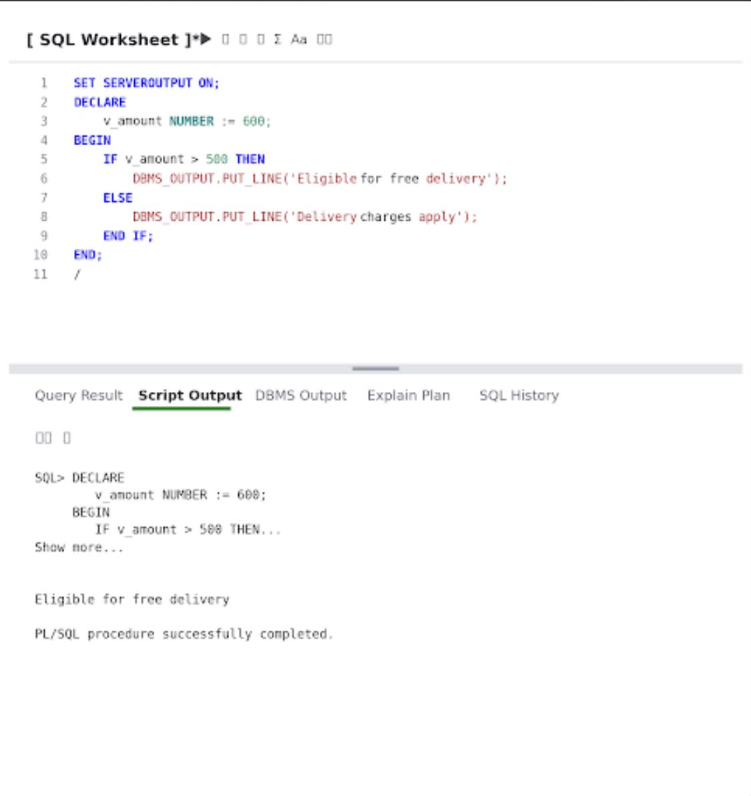
Task 3
Write a PL/SQL block that uses a simple LOOP to print the numbers 1 to 5 using DBMS_OUTPUT.PUT_LINE.
Query
SET SERVEROUTPUT ON;
DECLARE
v_counter NUMBER := 1;
BEGIN
LOOP
DBMS_OUTPUT.PUT_LINE(v_counter);
v_counter := v_counter + 1;
EXIT WHEN v_counter > 5;
END LOOP;
END;
/
Output:
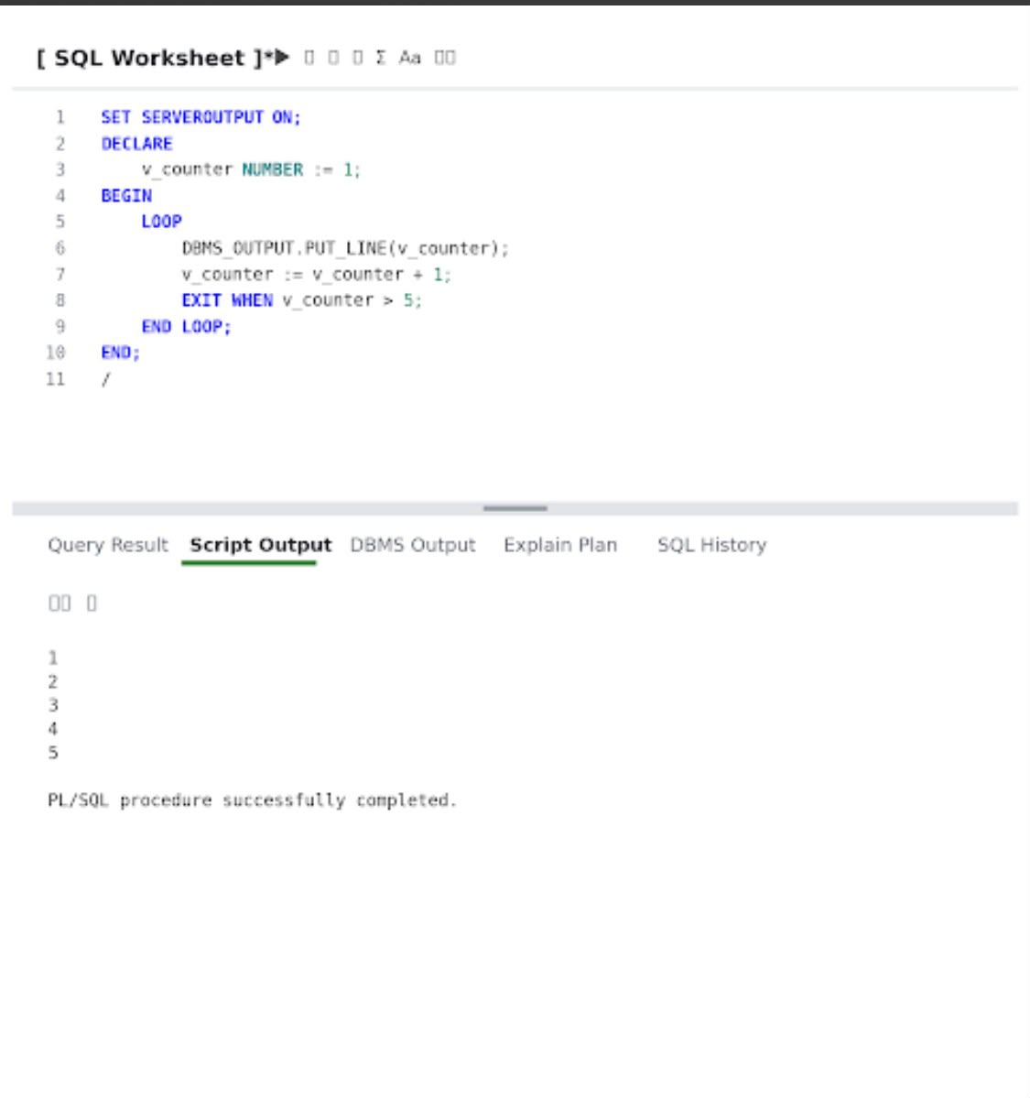
Task 4
Declare a cursor in PL/SQL to select all product names from a table called PRODUCTS. Fetch each product name and print it using DBMS_OUTPUT.PUT_LINE.
Query
PART A:
CREATE TABLE PRODUCTS (
PRODUCT_ID NUMBER,
PRODUCT_NAME VARCHAR2(100)
);
INSERT INTO PRODUCTS VALUES (1, 'Laptop');
INSERT INTO PRODUCTS VALUES (2, 'Mobile');
INSERT INTO PRODUCTS VALUES (3, 'Keyboard');
COMMIT;
PART B:
SET SERVEROUTPUT ON;
DECLARE
CURSOR c_products IS
SELECT PRODUCT_NAME FROM PRODUCTS;
v_product PRODUCTS.PRODUCT_NAME%TYPE;
BEGIN
OPEN c_products;
LOOP
FETCH c_products INTO v_product;
EXIT WHEN c_products%NOTFOUND;
DBMS_OUTPUT.PUT_LINE('Product: ' || v_product);
END LOOP;
CLOSE c_products;
END;
/
Output:
Table PRODUCTS created.
1 row inserted.
1 row inserted.
1 row inserted.
Commit complete.
Product: Laptop
Product: Mobile
Product: Keyboard
PL/SQL procedure successfully completed.
Task 5
Write a PL/SQL block that tries to divide two numbers entered as variables. If a division by zero occurs, catch the exception and print 'Cannot divide by zero'. Otherwise, print the result.
Query
PART 1:
SET SERVEROUTPUT ON;
DECLARE
v_num1 NUMBER := 20;
v_num2 NUMBER := 4;
v_result NUMBER;
BEGIN
v_result := v_num1 / v_num2;
DBMS_OUTPUT.PUT_LINE('Division Result: ' || v_result);
EXCEPTION
WHEN ZERO_DIVIDE THEN
DBMS_OUTPUT.PUT_LINE('Cannot divide by zero');
END;
/
PART 2:
SET SERVEROUTPUT ON;
DECLARE
v_num1 NUMBER := 20;
v_num2 NUMBER := 0;
v_result NUMBER;
BEGIN
v_result := v_num1 / v_num2;
DBMS_OUTPUT.PUT_LINE('Division Result: ' || v_result);
EXCEPTION
WHEN ZERO_DIVIDE THEN
DBMS_OUTPUT.PUT_LINE('Cannot divide by zero');
END;
/
Output:
PART 1:
Division Result: 5
PL/SQL procedure successfully completed.
PART 2:
Cannot divide by zero
PL/SQL procedure successfully completed.

